Nama : Yogi Prayogi

NIM : 18090010

Kelas : 5A

**PRAKTIKUM 1**

1. Source Code

Kenalan.php -> application/controller

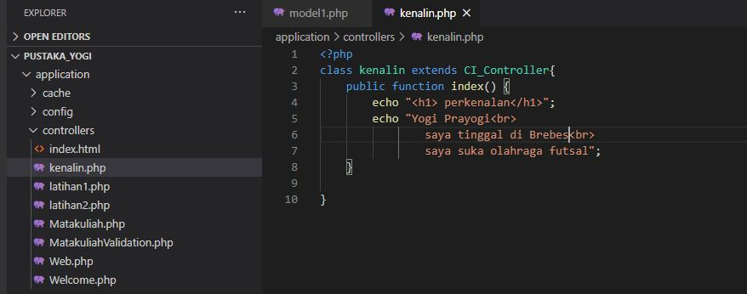

1. URL

<http://localhost/pustaka_yogi/index.php/kenalan>

1. Capture Hasil

